Choose a statement that explains the quote. Write it beside the quote, or write your own explanation.

- Citizens should take pride in being an essential part of our system of justice.

- Our constitution promises that a defendant has the right to be judged by their equals.

- Jurors must listen, understand, and then decide according to their principles and the law.

Who they were | What they said | What they meant
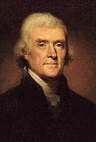  www.writespirit.net  Creative Commons License  Thomas Jefferson  President of the United States | "I consider trial by jury as the only anchor yet imagined by man by which a government can be held to the principles of its constitution."
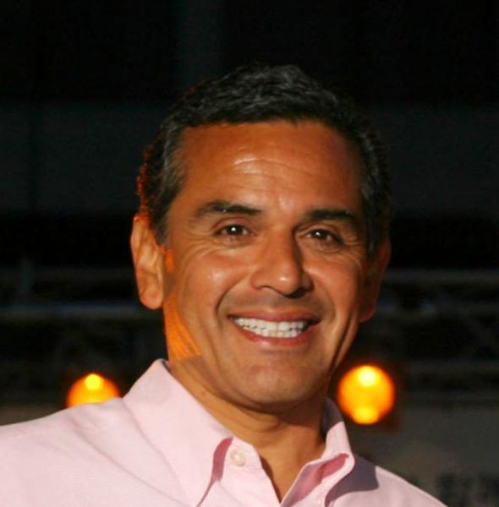  Wikipedia: Creative Commons  Antonio Villaraigosa  Mayor of Los Angeles,  Elected: 2005 | The great thing about our system of democracy is when they call you for jury duty, you have to come... It's an honor and a privilege. I was called and I've got to be here.
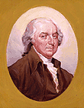  www.americanpresidents.org  Creative Commons License  John Adams  President of the United States | "It is not only his [the juror's] right, but his duty . . . to find the verdict according to his own best understanding, judgment, and conscience…

Some definitions

- anchor: a heavy object tied to a boat. The people sailing the boat throw the anchor in the water to stop the boat from moving.
- principle: a basic truth
- constitution: the written principles of a government
- system: an organized way to carry out an activity
- privilege: a special benefit
- right: a basic law that protects a country’s citizens and residents
- duty: responsibility
- verdict: the outcome of a trial)

